MRU | Department of Computer Science & Technology, MRU, Faridabad
MRU | Lab Assignment 4: Swings and Event Handling
Subject: Advance Java Workshop Subject Code: CSW308B Semester: V

Objectives

- To implement event handling in Java
- To validate the fields of a form
- To implement Advanced Swing

CO1, CO2
- In the form given below perform the following validations on Login Button Click.
- Every Field should be filled
- The password should be at least 8 characters long and must contain one digit.
- The Login should be successful only if User Name is “Student”, Password is “Student1” and Category is “Student” else the login should be unsuccessful.
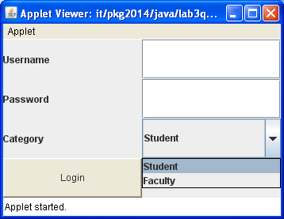
- In the form given below perform the following validations on Register Button Click.
- Every Field should be filled.
- Age should be numeric
- Contact Number should contain only digits
- Email Should be validated
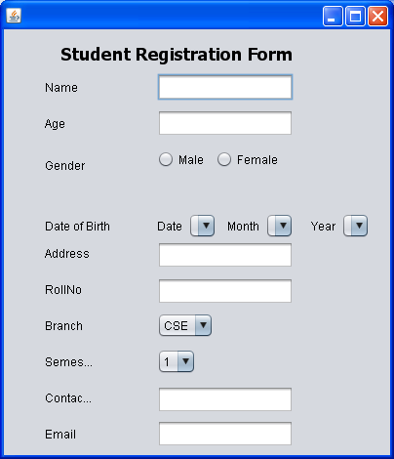
If the validations given above are meeting then display “Registration Successful”
- In the form given below on the click of the Add subject Button, the every detail filled by user should be displayed in a message Box and every field should be filled.
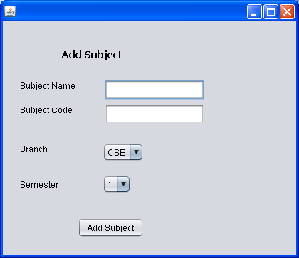

- Create a JTable that displays the details (Name, Code, Branch, and Semester) of five subjects.

- Create a Tree that displays the tree given below.
